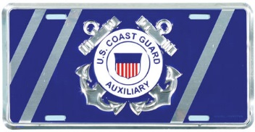

US Coast Guard Auxiliary / Susquehanna Yacht Club

2023
Basic Sailing / Sailing Skills / Seamanship Course
Starting April 5th thru May 24th

Pre-registration form for USCG Aux Flotilla 19-05 / Susquehanna Yacht Club
Spring 2023 Sailing Skills and Seamanship Course

Name of Attendee(s) __________________________________

Street Address ______________________________________

City _______________________________________________

State & Zip Code _____________________________________

Email address (to receive confirmation) ____________________

Phone _______________________

Course cost is $40 for one person and $60 for two people if sharing a book

Return this form by email to Wendy Behr at Wbehr118@gmail.com

